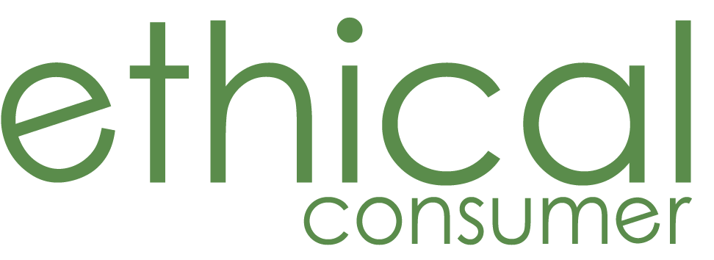
Unit 21, 41 Old Birley Street, Manchester M15 5RF
Tel: 0161 226 2929 Fax: 0161 226 6277
Website: www.ethicalconsumer.org
Subscriptions: shop@ethicalconsumer.org
Enquiries: enquiries@ethicalconsumer.org

16th October 2020

Dear candidate,
Thank you for your interest in the Covid Tech Tax Campaigner consultancy role at Ethical Consumer.

Ethical Consumer has secured funding from Network for Social Change to run a campaign for six months (26 days work) based around an article published by Rob Harrison and Josie Wexler at Ethical Consumer: https://www.ethicalconsumer.org/technology/big-tech-sales-tax

We are currently seeking someone to support us in delivering this campaign work.

This campaign work aims:

(a) To raise awareness of and promote discourse around the potential of a 10% windfall rate of Digital Services Tax to address pandemic-related social cost increases.
(b) To build an alliance with other groups and organisations which may support this proposal.
(c) To ask the government to introduce this measure, companies to wind down avoidance schemes, and for citizens to join the campaign.
(d) To use this specific issue as a lens to raise awareness of and promote discourse around a more general need for business to behave more responsibly in times of societal crisis.

Although the campaign is designed to address the UK, this idea, or line of discourse, could also prove very useful in other countries in similar circumstances.

As part of this role we also hope to secure funds to continue this campaign beyond the six months- building on the impact of the initial seed funding secured from Network for Social Change.

Timeline
We hope for this campaign role to work approximately one day a week (7 hours) for six months (26 days), ideally beginning in the first week of November 2020.

The timetable for this recruitment is as follows:
Closing date: 26th October 2020
Short-listing: 27th October 2020
Interviews: 29th October 2020
Starting date: Week beginning 2nd November 2020.

To apply, please send your CV (maximum two pages including references) and a cover letter (1000 words) to enquiries@ethicalconsumer.org

If you are short-listed for an interview, you will be notified by telephone and/or email.

Role description

Job title: Covid Tech Tax Campaigner

Location: Remote, home office essential

Hours: £2184 over 182 hours
This a temporary position split over 6 months (7 hours per week for 6 months). This role may be extended if funding is secured.

Responsibilities
The precise nature of the work will be agreed with Ethical Consumer. However, as part of the this consultancy role, you will need to:
- Work with Ethical Consumer to develop a campaign strategy and timeline for this work.
- Respond quickly on social media to government and company interventions in this space.
- Systematically contact government, companies and citizens asking them to take action.
- Build alliances with like-minded groups – working with and building on Ethical Consumer’s current network.
- Conduct ongoing research and publishing for Ethical Consumer magazine and website on this subject.
- Support Ethical Consumer in securing funding to continue this campaign work beyond the six months.

Person specification

Essential Qualities
- Ability to work independently and as part of a team.
- Experience of running successful campaigns.
- Experience of building collaborative partnerships or alliances.
- Ability to understand and analyse written information, and summarise it using clear and concise language.
- Ability to behave in a confident and professional manner towards colleagues, clients and other relevant contacts.
- Excellent organisational skills and ability to meet deadlines.
- Good computer literacy.
- Good communication skills.
- Attention to detail.

Desirable Qualities (training can be provided)
- An understanding of corporate tax avoidance strategies.
- Experience of using social media for campaign purposes (including twitter).
- Experience of writing for different audiences.
- Experience of research and information gathering in a range of formats. including the internet and telephone.

To apply, please send your CV (maximum two pages including references) and a cover letter (1000 words) to enquiries@ethicalconsumer.org by the 26th October 2020.

In writing your CV and cover letter, please refer back to the essential and desirable qualities stated above and draw on both paid and voluntary work. Ethical Consumer is an equal opportunities employer and welcome applications from all sections of the community.

If you are short-listed for an interview, you will be notified by telephone and/or email by the 28th October, with interviews being held on the 29th October.

If applying, please note this work aspires to commence immediately - in the first week of November.

